1. Oracle VM box and Ubuntu 22.04 version is installed.

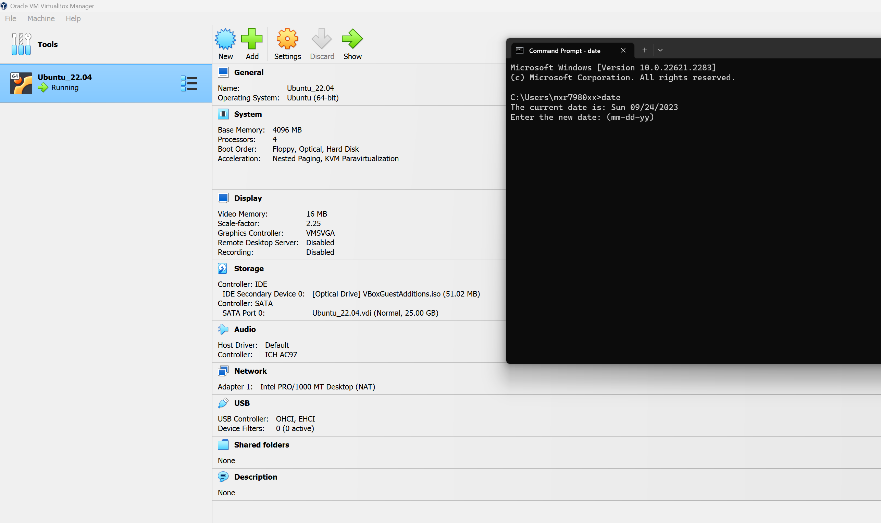

1. Check the Ubuntu Version First

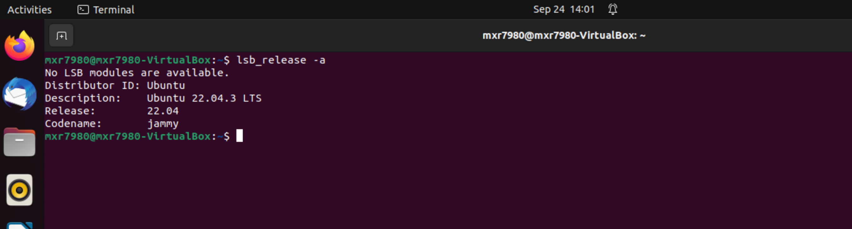

1. Installing gnome-terminal

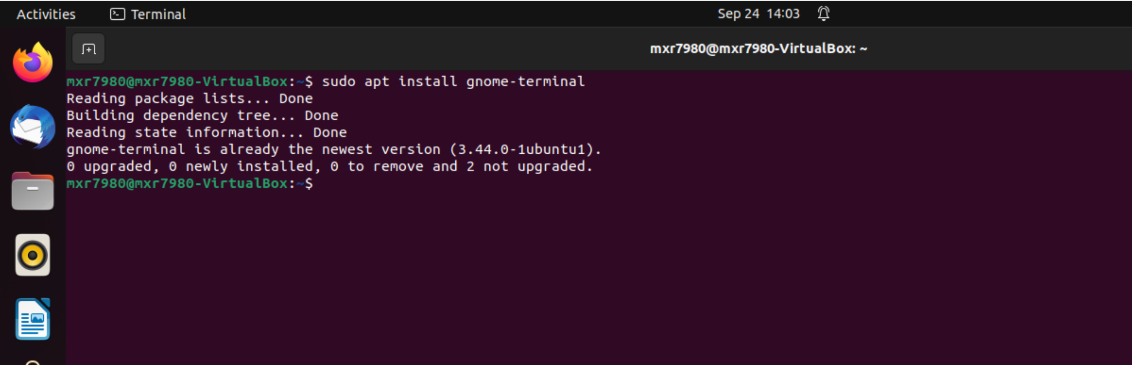

1. Uninstall any previously installed docker version

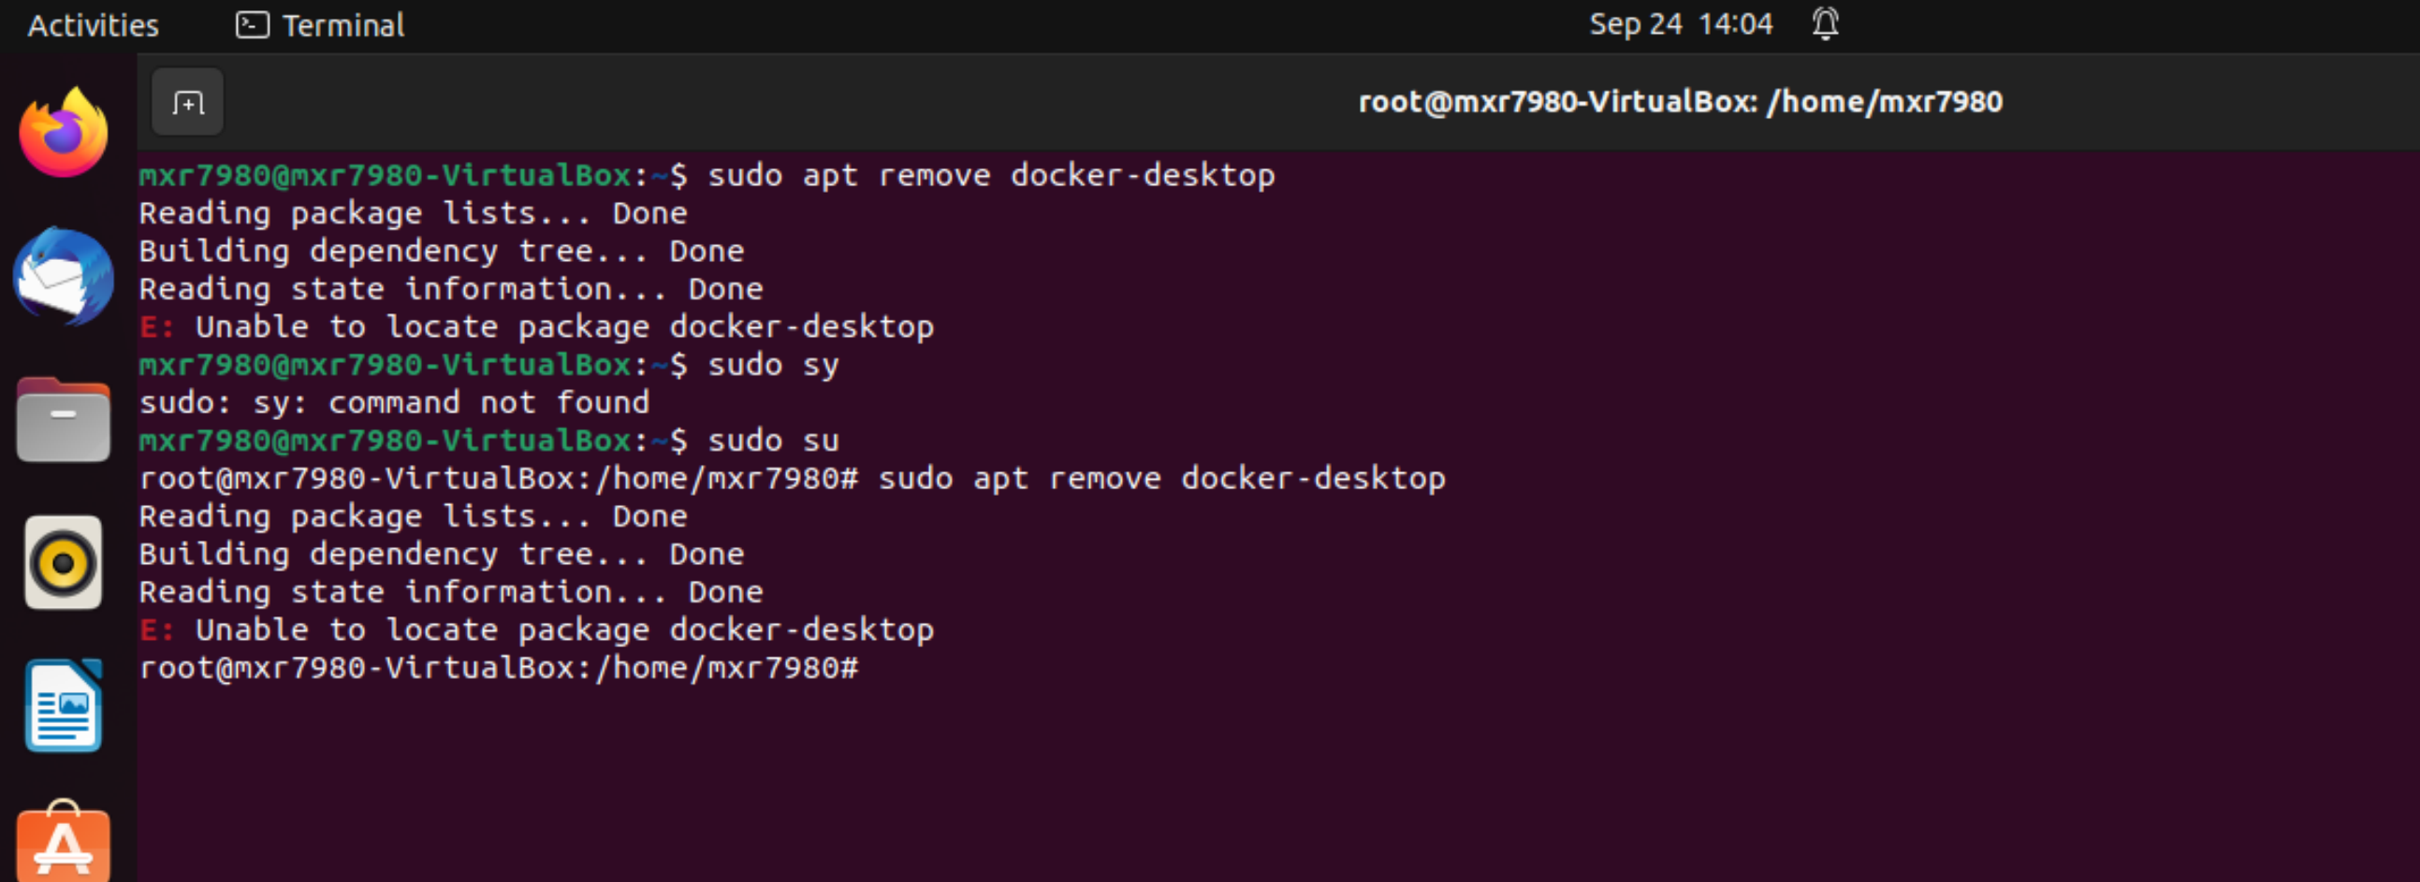

1. Update and Upgrade the package list to ensure you have the latest package information:

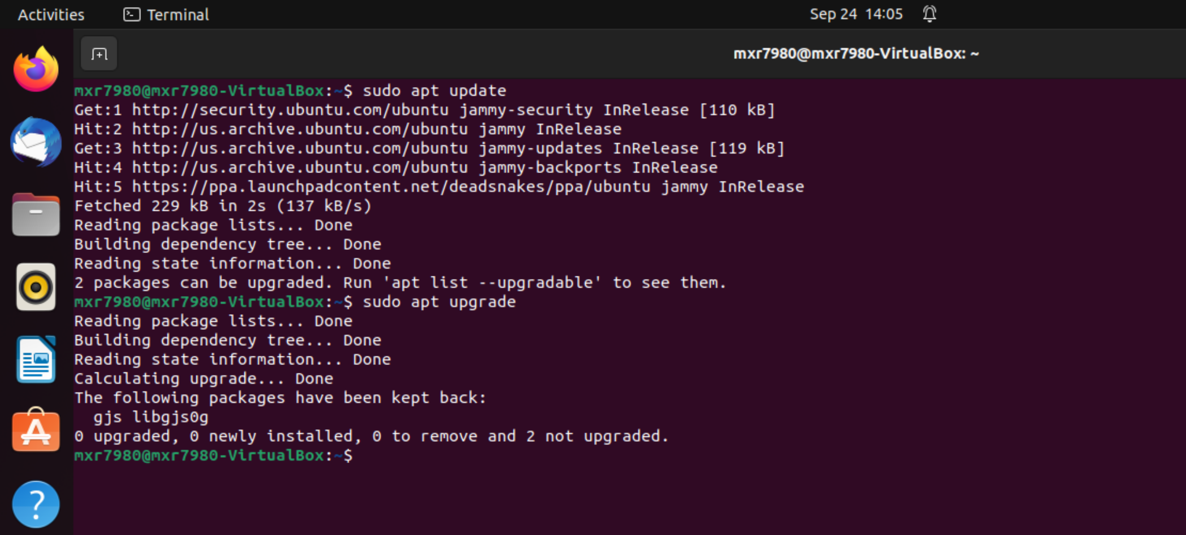

1. Installing Docker

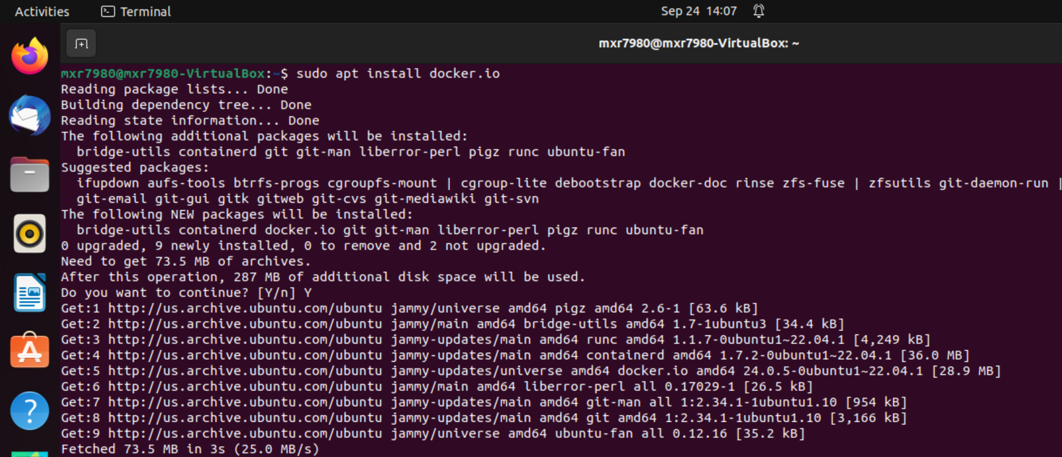

1. Start the Docker service and enable it to start on boot

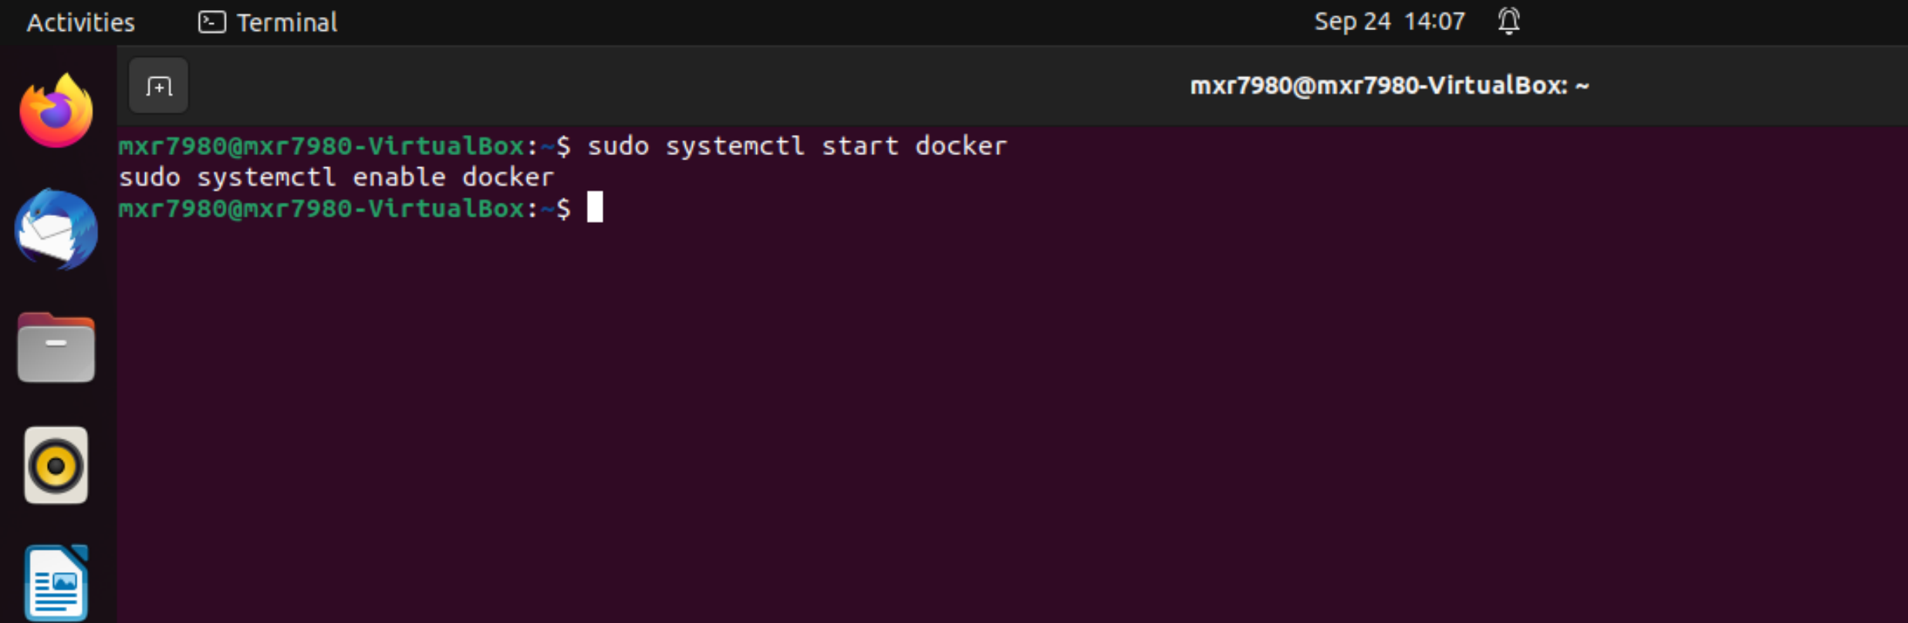

1. Creating a subnet for this docker

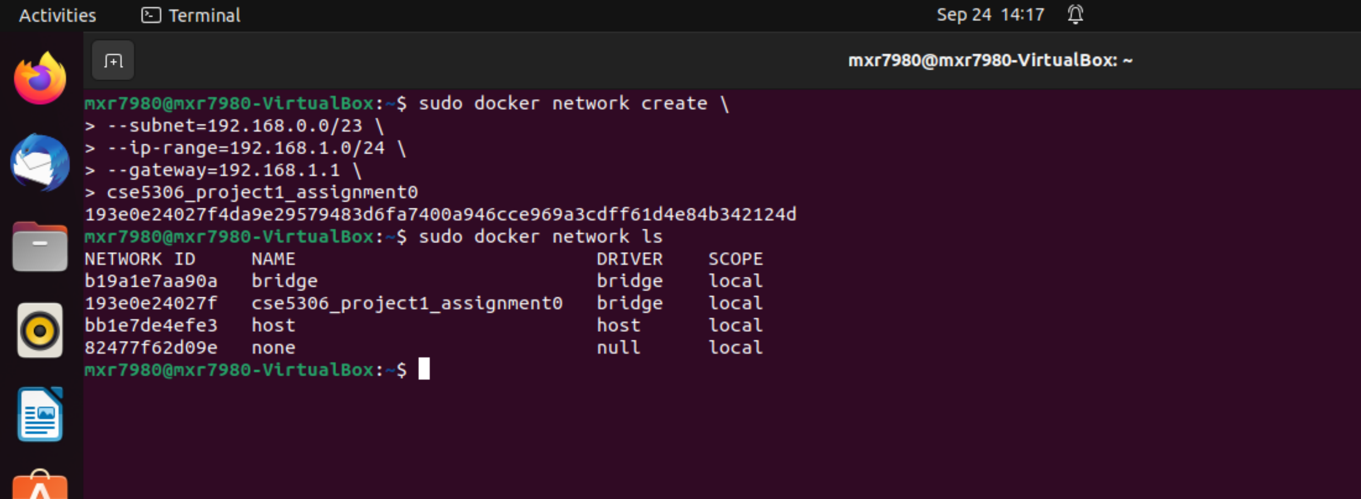

1. Creating a client and server in the docker

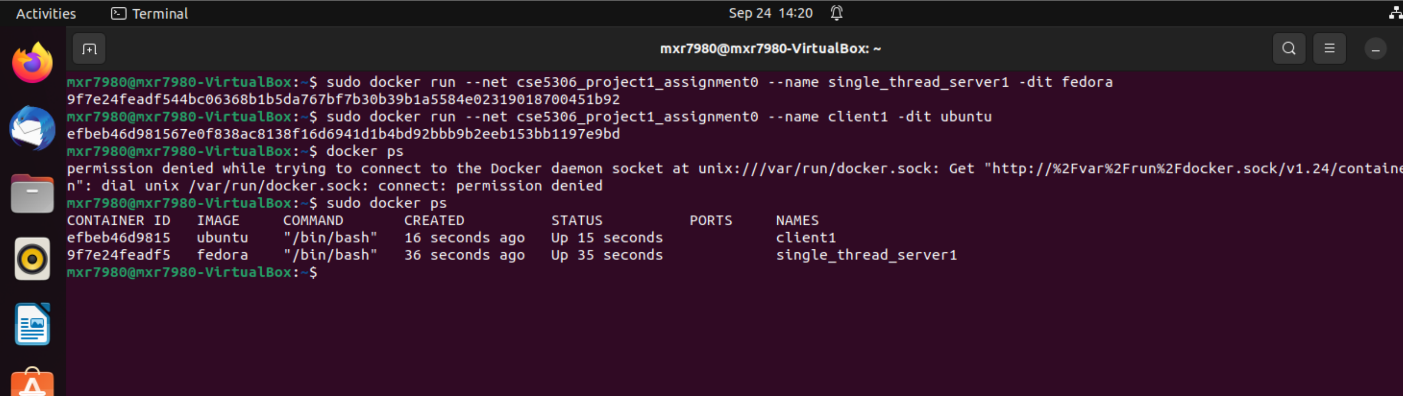

1. Checking the IP_addresse of the client and server

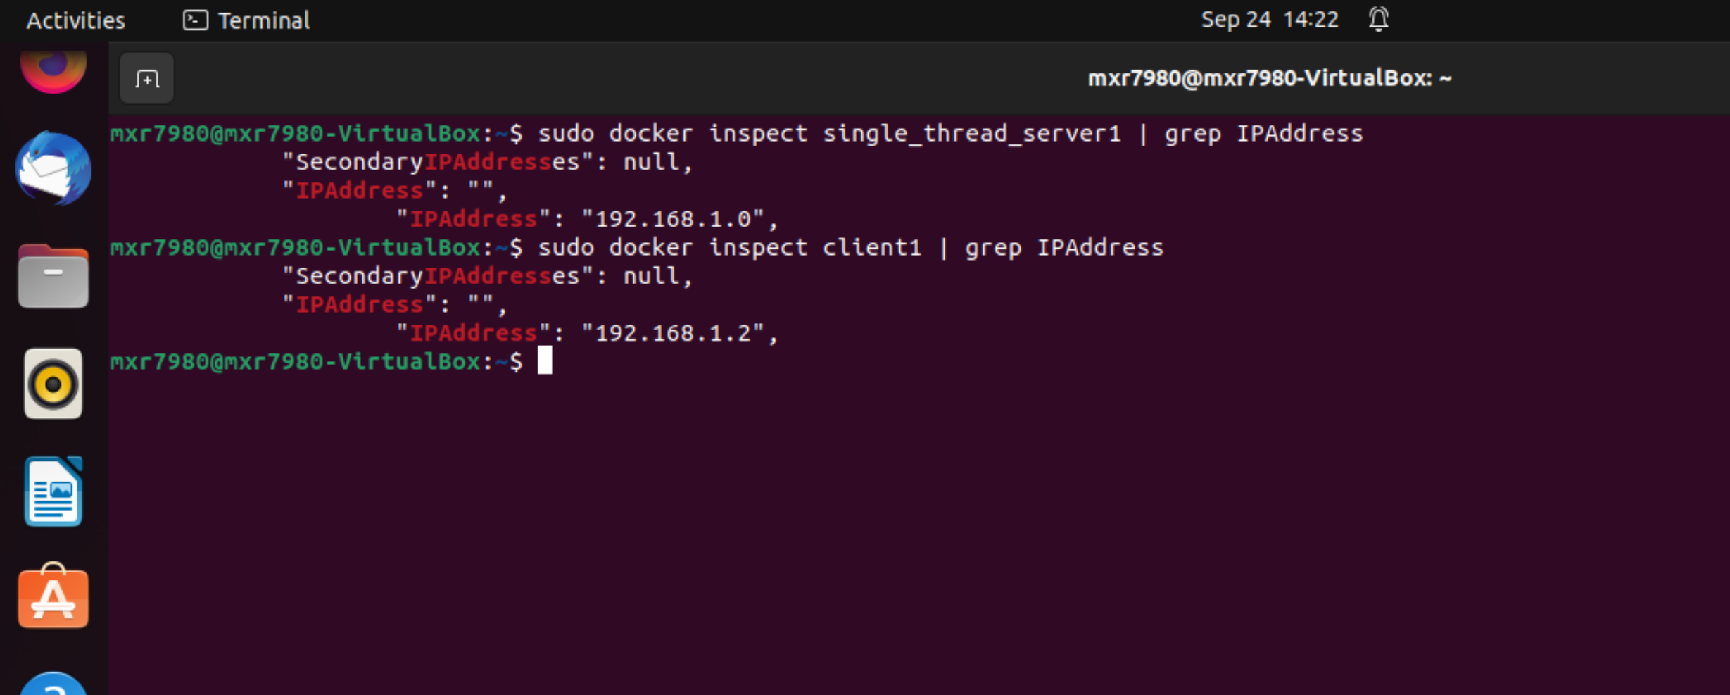

1. Client and Single_Thread_Server are communicating

